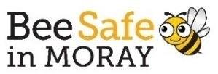
Top Tips for Secondary Learners

Before going to school:

- If you feel unwell, you should not go to school and should tell someone at home – are you hot, have a new continuous cough or lost your sense of smell and taste?
- Make sure you have breakfast and wear warm clothes during winter months
- Please ensure you dress warmly for Physical Education (PE) as this may be outside, even in winter months
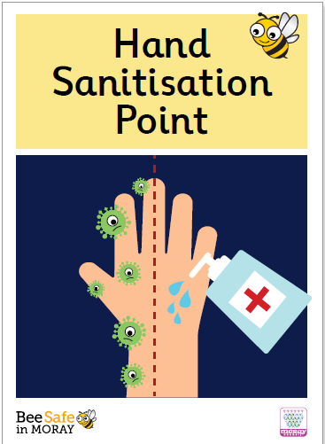
- Make sure you have packed everything you need for the day including your own hand sanitiser and tissues if you want
- You should bring a face covering/mask with you to school unless exempt
- Face coverings/masks and social distancing must be adhered to
- Wash your hands before you leave the house (20 seconds)
- Avoid touching your face, eyes and mouth at all times

When travelling on school or public transport:

- If you can, walk, cycle or scoot to school as a healthier option
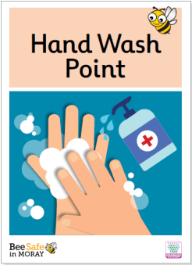
- Hand sanitise before going on to school or public transport
- Face coverings/masks must be worn unless you are exempt from wearing one
- Don’t eat or drink on transport
- Avoid touching seats, handles and surfaces if you can
- Keep 2 metres away from adults
- Remain in the same seat each time you are on school transport and ensure you are on the assigned bus

When arriving at school:

- Face coverings/masks must be worn in corridors, communal areas, toilets and if within 2 metres of others
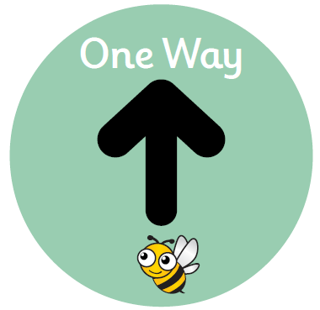
- Arrive as near to the start of the school day as you can – don’t be late!
- Avoid gathering with others in groups
- Follow instructions from adults
- Wash your hands and hand sanitise regularly
- Avoid standing at busy areas – for example, at entrance doors
- Be kind and respectful at all times and follow rules for everyone’s safety

During the school day:

- Wash your hands regularly, dry them properly and hand sanitise
- Move around the school and classroom only when you need to
- Use toilets at break and lunch times where possible - moving around during class times will be limited
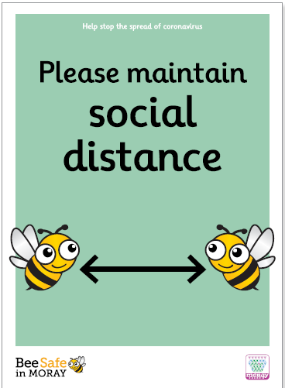
- Stay in your allocated seat in classes
- Don’t share equipment
- If you use tissues to sneeze/cough, put them in the bin and wash your hands
- Avoid touching other people, handshakes and hugs
- Follow instructions given by staff at all times
- If you feel unwell at any time, tell a teacher or an adult straight away
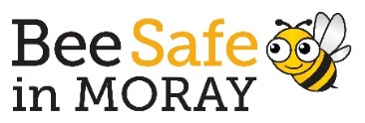

At break and lunch times:

- Wash your hands and hand sanitise
- If you feel unwell, tell someone straight away which may involve going to the School Office
- Put all rubbish in bins provided and recycle where possible
- Adults on duty will help you when moving around the school. Please follow their instructions to keep everyone safe
- Identified year groups may be allowed to leave school premises at lunchtime. Please be a good neighbour and be respectful of others and the community around your school
- If leaving school premises at any time, please remember to adhere to social distancing, wearing face coverings/masks in shops and disposing of your litter in a refuse bin to keep the local area tidy
- Shops may impose limits for entry to support social distancing and you should be respectful of this request

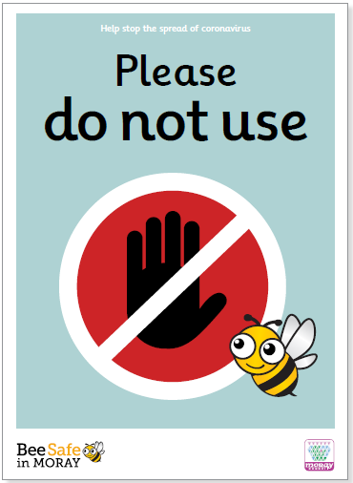
At the end of the school day:

- Follow instructions from school staff
- Leave the building, taking all personal items with you
- Use the correct exit route and exit door
- Avoid gathering outside the school building or on the way home from school
- Be kind and respectful to people and the area around the school

When you return home:
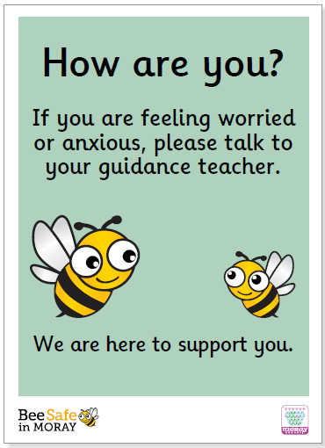
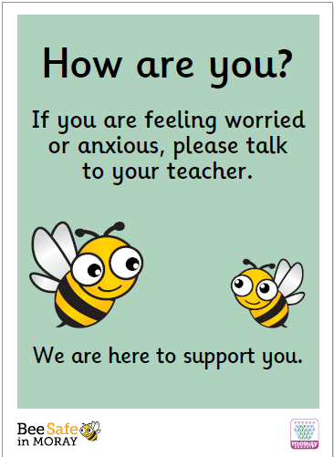
- Wash your hands and hand sanitise
- You may want to change out of your school uniform
- Remember to do your homework or studying to be prepared for any Senior Phase assessments

At all times:

- Please be kind and think of others
- Please follow all rules, arrows and instructions
- Try your best and be supportive of one another
- If you are anxious or worried, please talk to someone you trust who can help you

If you are identified as a close contact to someone who has been tested positive for Covid-19, please ensure that you follow school arrangements for continuing your learning remotely at home during any period of self-isolation. Your school will keep you updated.

We will continue to do everything we can to make you feel safe in school and to support you with your learning.
