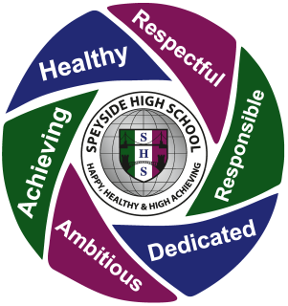 | Lesson Charter  Positive relationships policy used to ensure no-one misses out on learning.
Lessons Start:
- Promptly and positively with pupils greeted and all having a positive attitude and appropriate resources.
- With an established routine e.g. starter activity.
- By recapping on previous learning to ensure understanding and connections and develop Learning Intentions, Success Criteria where appropriate.
- A shared understanding of where particular lesson/lessons sit in overall scheme and its relevance.
Lessons Continue and Develop With:
- A positive learning atmosphere developed where everyone works collaboratively and with respect.
- Pupils are actively involved in their learning and learning supports independence – and ideas valued.
- Learning that is engaging, and provides appropriate pace and challenge for all.
- Questioning is well used to check on all pupils understanding (AifL Bloom’s taxonomy).
- Pupils receive SHS feedback to ensure they know how to progress and to set targets.
- Pupils are offered personalisation and choice within curricular area.
Lessons Conclude With:
- Revisiting of LI and SC to gauge understanding.
- Evaluation activity of lesson and learning when appropriate.
- Celebration of success of lesson.
- Use of exit passes as appropriate and a connection to next lesson.
- Encouraging home and family learning including use of SMHW.
- A leaving room routine – to ensure readiness for next learning experience.

