

Pupil Equity Fund
- a guide for families

2025-26

“Every child should have the best possible start in life, no matter their background. Schools have a significant role to play in ensuring every child is given the right support to help them achieve their full potential”

Why have a Pupil Equity Fund?

Speyside High School receives approximately £17 000 per year currently to support young people within our school. The key issues which we aim to address are:

What does this look like at Speyside High School?

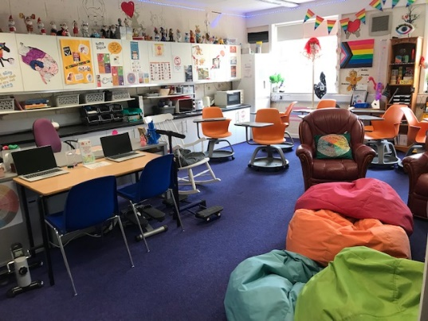
Inclusion Support Officer
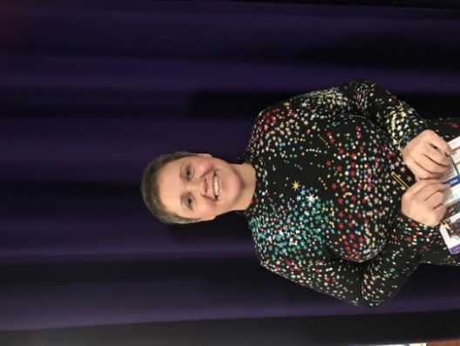
Our inclusion support officer Sarah Thornhill runs the Wellbeing Hub to supprt physical, mental, emotional and social wellbeing. The Wellbeing Hub can be used by young people to self-regulate, to provide a safe space to work and as part of flexible learning timetable.

< Sarah Thornhill

Wall of wonders
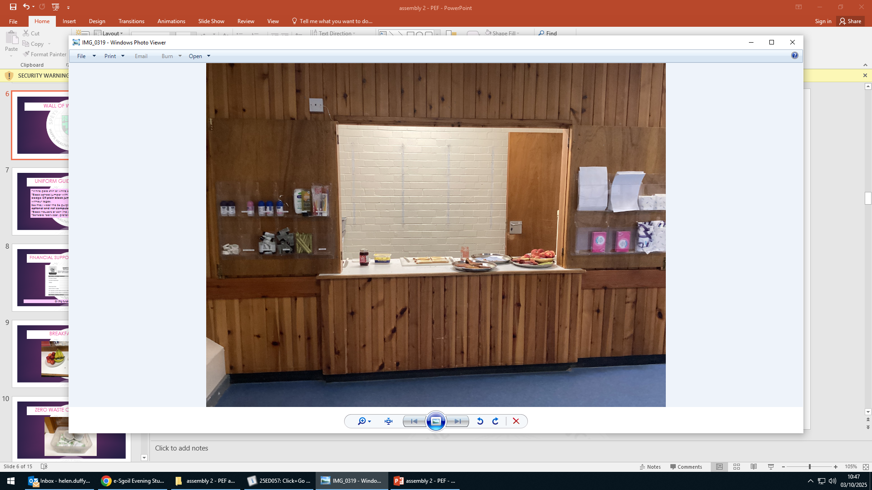
The wall of wonders sits just outside our breakfast club hatch and is open to all young people before the start of the school day. It contains a variety of useful products to support health and wellbeing including, deodorant, toothpaste, soap and shampoo. It is completely free – all we ask is that young people only take what they need.

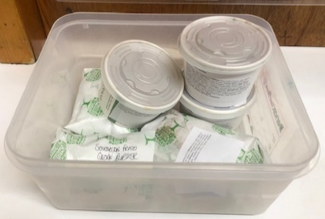
Reducing food waste
The canteen is now offering food at the end of the day outside reception which has not already been sold. This includes soups, sandwiches and certain main meals and includes reheating instructions.

Breakfast club

Breakfast club is open to all young people every morning from 8.20-8.45am. Food offered includes toast and butter/jam, croissants, fruit and cereal bars. This is organised by Mrs Duffy and funded through grants from the Coop, Tesco and our local church.
Mrs Duffy >

Mentoring
S1s are offered a mentor at Speyside High School to support their transition into high school and this offer is targeted from S2 upwards. Mentors meet regularly and there is a chance to discuss any worries or concerns. This is shared with the young person’s Guidance teacher and sent home to parents / carers.

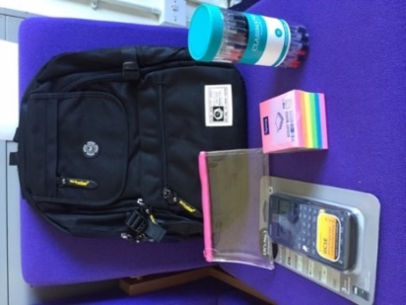
Equipment
A range of free resources are available for young people including bags, stationery and water bottles. This can be requested through speaking to their Guidance teacher. Young people can also always pick up pencils, rulers etc at reception as they come into the building with our ‘pick up a pencil’ initiative.

Each S1 within PEF has also been offered a water bottle, pencil case and calculator. This is organised by Mr McWhirter.

< Mr McWhirter

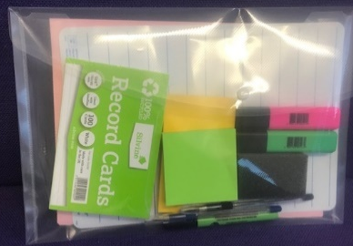
To support those in S4-6 we can provide revision support packs which include a whiteboard and marker, highlighters, post it notes and flash cards along with revision strategy reminders. There are also free revision resources also available in the library.


Laptops and tablets
For families who do not have a computer at home we have access to free laptops which can be handed out to support home learning. For young people who do not have internet access at home, we are also able to provide a WiFi access point which runs on the Vodafone mobile network.
For young people who previously used mobile phones to support class learning (e.g. taking photos of the board / their work or to listen to music) we also have access to free tablets.
Please contact Mr McWhirter or Mrs Duffy for further information.
Supported by Reboot, the Moray Council and William Grant Foundation



Uniform and Clothing

In partnership with Moray School Bank we run a ‘No Waste Wardrobe’ to share free school uniform and other essential clothing such as winter jackets, shoes and PE kit. We also offer Christmas jumper and party clothing in December. The wardrobe can be accessed during the school day through Sarah Thornhill in the hub, Guidance teachers or our pupil volunteer group shown below. It is also laid out for anyone to take what they need from a table outside the auditorium during the school day and at parents’ evenings. We also have a range of uniform available at Tomintoul, Glenlivet and Mortlach primary schools for parents to collect from.
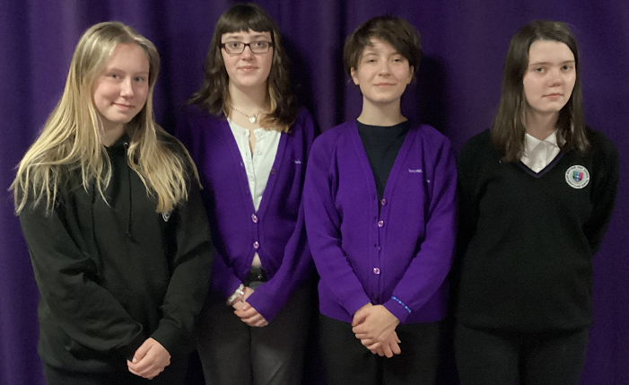
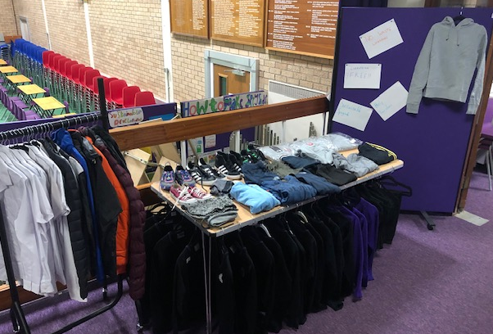

Our volunteers Kaysie, Ollie, Rhiannon and Devon
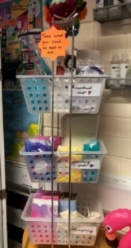
Sanitary products
Free sanitary products are available at all times at various locations across the school including the hub and the wall of wonders.

Literacy and numeracy support

Additional support for young people with literacy and numeracy happens with either in class or out of class support. This may be short one-to-one sessions with Mrs Stewart or within a group in class. For those not accessing mainstream education this may happen at another location outside the school e.g. the local primary school or community library. Mrs Stewart >

Community partnership project

Targeted young people within S1-3 are given the opportunity to take part in a free literacy / numeracy outdoor learning project to enhance their sense of confidence, participation and self esteem as well as improve their literacy and numeracy. We work alongside Outfit Moray who offer a range of outdoor activities including zip lining, bush craft, archery, abseiling and orienteering. To help develop family connections, parents / carers are invited along to take part in the event and also to a presentation event where young people showcase their learning.



Sources of additional funding for families

A tool has been launched to help guide you through the first steps to access money advice in Moray if you're worrying about money. Please visit the webpage below for more information: www.worryingaboutmoney.co.uk/moray

School trips / activities
We are aware that paying for trips for young people can prove challenging. Teachers organising trips are made aware of sources of funding to try to reduce the overall costs to young people as much as possible. In addition to this, they will take into consideration any young person entitled to free school meals who is interested in attending the trip and discuss with the family / Guidance teacher any appropriate supports.

The Banffshire education trust provides funding for families to support their young people to take part in educational trips. Applications are considered on an individual basis and can fund part or even the whole cost of a trip. Applications can be made by a family using the travel grant application form found on the Moray Council website:
www.moray.gov.uk/moray_standard/page_43907.html

Clothing grants
Families on low incomes may be eligible to receive a school clothing grant award of £150. The award is given annually to help with the cost of buying school clothing. The application form can be found on Moray Council’s website:
www.moray.gov.uk/moray_standard/page_55486.html

Free school meals
Families on low incomes may be eligible to receive free school meals. The daily allowance of £2.65 is available to spend at break time and lunchtime. The application form can be found on Moray Council’s website:
www.moray.gov.uk/moray_standard/page_55486.html

Educational Maintenance Allowance (EMA)
If your young person is aged 16-19 years and attending school or college, you may be eligible to receive financial assistance from an Education Maintenance Allowance (EMA). EMA is a weekly allowance of £30 per week payable to eligible young people who stay on in full-time education after their 16th birthday or participate in an Activity Agreement. The application form can be found on Moray Council’s website:
www.moray.gov.uk/moray_standard/page_40540.html

School leavers
Students Awards Agency for Scotland (SAAS) provide grants for full time courses at HNC, HND, degree or equivalent level. Courses below HNC may qualify for a College Bursary. Additional financial support may be available for young people with disabilities or who are care experienced or estranged. www.saas.gov.uk
Scholarship Search is database of awards available for those wishing to attend an undergraduate course in the UK. www.scholarship-search.org.uk
Learndirect provide advice on childcare and the availability of funding. www.learndirect.com
Student Loans Company can help pay for university or college tuition fees and to help with living costs. www.gov.uk/government/organisations/student-loans-company

We hope you find this document helpful. If you require any support in completing any of the forms or wish to discuss any of the supports offered further, please speak to your young person’s Guidance teacher in the first instance or email the school office using the email address below:
admin.speysidehigh@moray-edunet.gov.uk


Helen Duffy – Depute Head Teacher

